ADDENDUM 1
TCAT, INC. Request for Proposals #401-2019 Farebox Replacement System
May 1st, 2019
Revised dates
Day/Date | Description
April 15 (Week of) | Announcement of RFP also placed on New York State Contract Reporter and TCAT, Inc. websites.
April 15, 2019 | RFP copies available to suppliers via e-mail and websites.
April 29, 2019 | Pre-bid On-site or Call-in at 2:00 PM  CONTACT TCAT FOR INVITATION WHICH WILL INCLUDE CALL IN NUMBER
May 15, 2019 | Written questions due
May 22, 2019 | Written replies to questions distributed to all known parties.
May 31, 2019  No later than 4 PM DST  Late bids will not be accepted. | RFP responses due at following address:  TCAT, Inc.  737 Willow Avenue  Ithaca, New York 14850  Attention: Raymond Lalley  Submittals Due By 4:00 PM DST
Completed no later than June 14, 2019 | Responses will be analyzed and scored by TCAT, Inc. evaluation team. Total scores will factor heavily into TCAT, Inc.’s decision as to which parties are considered finalists
June 21, 2019 | Down selecting of vendors to be notified
To be scheduled | Presentation of offering
July 29, 2019 | TCAT, Inc. project award is made (subject to successful negotiations of terms and conditions).

Who we are? TCAT provides public transit bus service in Tompkins County, which includes Cornell University, Ithaca College, the City of Ithaca, and all surrounding rural villages within the county.
Why we are changing? Current provider is discontinuing all support May 31, 2020. However we would like to start a new system by January 1 if possible because many regular riders will be out of town for winter break and because we would prefer to have the new dataset start at the beginning gof a calendar year.
What we are currently using? Brightworks Computer Consulting of Ithaca NY provided a one off solution tailored to TCAT; the TCAT farebox solution is no longer a part of Brightwork’s core business. The system supports proximity (RFID) and magnetic stripe technology and has a touch screen driver interface to record the depositing of cash into a legacy cash dropbox.
IMPORTANT: Validating farebox clarity, TCAT uses the term to refer to the validator of fares, processing unit. It is not a cash validating equipment. Sorry for confusion.
Q: Is there a DBE goal?
A: Not for this project.

Highlights from the meeting held on April 29, 2019
- Starting on page 9-13 refers best to the general RFP requirements.
- pp 21 important reminder design life 10 years
- pp 22 important reminder nonproprietary technology
- pp 24 and pp 99 data security (PCI DSS) credit card responsibilities and liability will be on the vendor for processing payments in a system maintained by the vendor, or subcontractor either identified or under the vendor agreement.
- pp 63 and 71 Broadband cellular service, we will have a LTE, Wi-Fi, and GPS connections available
- Pp 64 Garage Communications Server –depending on solution this may not apply, we are aware and understand this configure is not required.
- Pp 76 Administrative POS Terminal – Remove the portable Administrative POS Terminal Requirement
- Pp 90 – Touch Screen is optional not required; Cash Drawer – not required; Digital Camera and Tripod – not required
- Pp 109 Desired reports – General not exact, SQL access a positive, line 42, 42, Smart Card should be replaced with proximity cards
- Pp 121 – 125 TCAT Legacy Systems Interfaces – Deleted requirement, we will not be interfacing to existing systems, except as optioned for the Avail solution
- Pp 124 – Real time location is independent, referenced CAD AVL Software is reference, the standard approach this will not have integration.
- Pp 130 – Web Portals, we are working currently with RK Software with existing platform and will assist in providing transition support.
- Pp 149 – Describes the standard proximity card, there may be references to standards for the smart card. However, smart card requirements are only with the option.
- Pp 150 – Refer to the pricing sheet change in card quantity
- Pp 159 - Design Review – Standard, low customizing at first. Due to timing and cost.
- Pp 165,6 – Multi-Function Vending Machine Cycle Testing related to option, not part of the standard requirement.
  - When and how many MFVM planned for the future? No current plan to implement, it is dependent on cost and available funding.
- Pp 193 – As-Built Drawing – Not a requirement, we need to just see the equipment list details, with finer elements, i.e. cabling, connectors, power supply details, converter, internal replacement parts, etc.
RFP Deliverables:
Pp 204 – Options
- Avail integration to relate route data with fare collection data. There may also be an opportunity to use the Avail MDT touch screen to record cash fares. Respondents will have to discuss this option directly with Avail Technologies.
- Smartcard. What are your future plans? We are looking as this a future solution for mobility as a service. We are looking to this technology to grow as we look at other forms of service.
- The industry is using smartcards, can we provide a proposal? Yes, indicate proximity card readers are not an option, and indicate cost of the smart card pricing with the spreadsheet. We at TCAT do not wish to be a one-off solution, or have time for a custom solution due to the end of life of our current system.
Pp 275 – Question form referenced is not required. Emailing of the questions is preferred. ALL questions will be shared with all known vendors, and added to addendum(s).
Pp 277 – Pricing breakdown based on deliverable milestone payment it is negotiable; the spreadsheet for pricing updated to our website.
Pp 294 - Required forms, checklist on pp 294. Change only need 1 original inked and stamped copy, and prefer you provide electronic copy, email, USB, or CD. The original must be provided by the date within the RFP, May 31 at 4 PM. pp 303 – lobbying and debarment and pp 316 Buy America Certification; duplicate lobbying and debarment is duplicate, only require one signed instance.

Equipment Details
Diamond cashbox is model RV
Our current farebox system created by Brightworks has a current modem in place, Multi-tech MTC-H5-B01, HSPA+ Modem (RS-232).
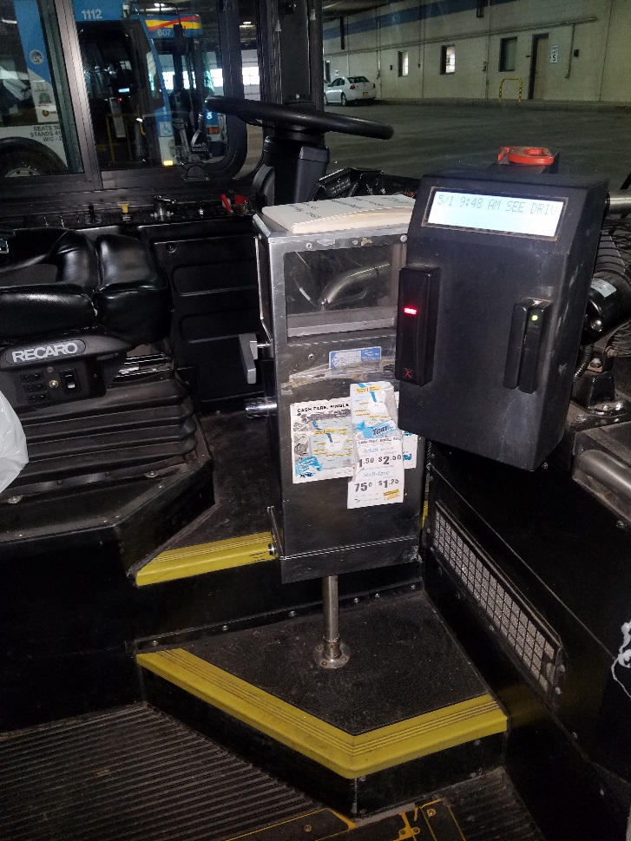
Photos of our current units used with Brightworks:
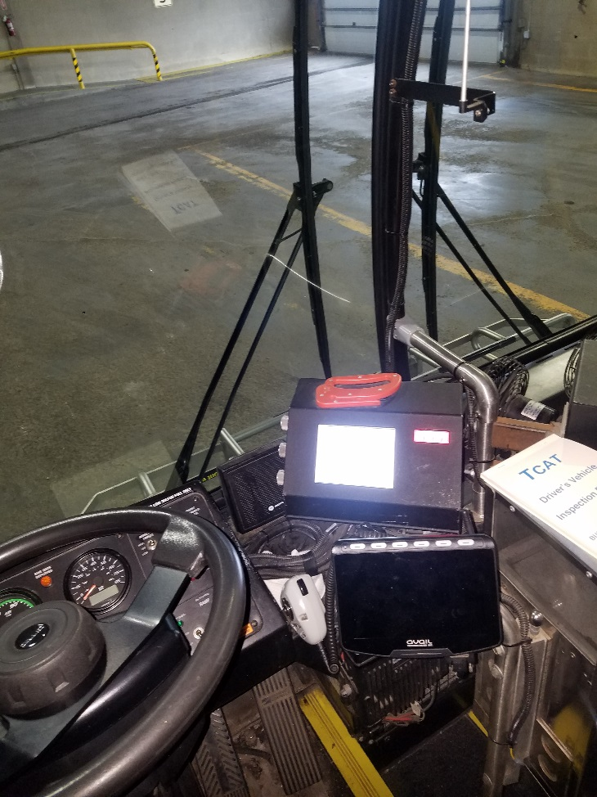

RFP Corrections:
Page 25 – Stand-alone processor – remove reference
Pp 41 – General Fare Policy Requirements, “C” …”passback parameter for stored value transactions shall be adjustable.”
Pp 76 Administrative POS Terminal – Remove the portable Administrative POS Terminal Requirement
Pp 121-125 “TCAT Legacy System Interface” removed
Pp 128 under GCS Application SW, remove the word SAP. We utilize SQL databases (Tom can elaborate)
Pp 196 – Change M-FCSU with T-FBR

